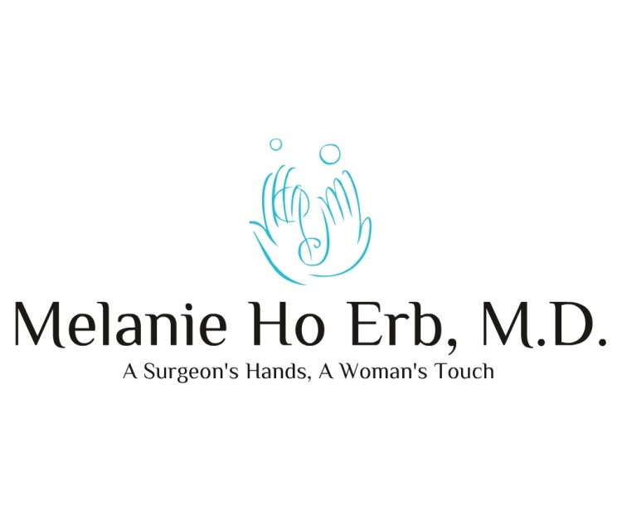
Laser Cosmetic and Oculo-Facial Plastic Surgery
Wish List - Reason for Visit
Today's date: ______________________________________
Name:____________________________________________

What issues and wishes do you want to discuss with Dr. Erb today?
___________________________________________________________________________________
___________________________________________________________________________________

When you like to accomplish your wish?

( ) ASAP ( ) 1 mo. ( ) 3 mo. ( ) 6 mo. ( ) 1 year

Would you be interest in learning more about any of the following procedures?

( ) Improvement in any skin conditions such as
- wrinkles
- loose skin
- brown spots
- scarring
( ) Fillers (Juvederm, Restylane,etc) to improve deep lines and to add youthful volume
    - to hands
    - to lower eyelids
    - to temples
    - to lips
    - to other parts of face
( ) Botox to improve or prevent wrinkles
( ) Kybella to improve a double chin
( ) Laser skin resurfacing to improve skin radiance, luminosity, spots, sun damage, and fine wrinkles
( ) Laser upper blepharoplasty upper eyelid lift for a more refreshed appearance
( ) Laser lower blepharoplasty improvement of lower eyelid bags for a more refreshed appearance
( ) Brow lift to raise brows to a more youthful position
( ) Ptosis repair to raise droopy eyelids
( ) Removal of bumps to provide a smooth appearance
( ) Gel peel treatment facials customizable peels to tighten, brighten, and hydrate
( ) Skin care multifunctional products from organic to medical grade – to deliver
optimal results

Patient signature____________________________ Reviewed by Erb_____________________

